**Bayer Low Tunnel Volatility Study**

Summary of 20-ARL-SB20 study

*Rodrigo Werle1, Ryan DeWerff 2, Nick Arneson3, Sarah Striegel 4, Nikola Arsenijevic5, Felipe Faleco5, Kolby Grint5, Haleigh Ortmeier-Clarke5, Jose Nunes6 and Emily Glaeser7*

*1 Principal Investigator, 2 Research Technician, 3 Outreach Research and Extension Associate, 4 Former Graduate Student, 5 Graduate Student, 6 Visiting Scholar,*

*7 Undergraduate Research Assistant*

Questions on the contents of this report should be directed to Rodrigo Werle (rwerle@wisc.edu) and Sarah Striegel (sstriegel@wisc.edu).

**

**Contents**

Methods...................................................................................................................................... 5

Results......................................................................................................................................... 7

**List of Figures**

Figure 1. XtendiMax with VaporGrip + Roundup PowerMax at 28 DAT.................... 12

Figure 2. XtendiMax with VaporGrip + Roundup PowerMax + Intact at 28 DAT.... 13

Figure 3. XtendiMax with VaporGrip + Roundup PowerMax + Impetro II at 28

DAT.......................................................................................................................................... 14

Figure 4. XtendiMax with VaporGrip + Roundup PowerMax + MON 51817 –

VaporGrip at 28 DAT............................................................................................................ 15

Figure 5. XtendiMax with VaporGrip + Roundup PowerMax + MON 51817 –

VaporGrip + Intact at 28 DAT............................................................................................. 16

Figure 6. XtendiMax with VaporGrip + Roundup PowerMax + MON 51817 –

VaporGrip + Impetro II at 28 DAT................................................................................... 17

Figure 7. XtendiMax with VaporGrip + Roundup PowerMax + MON 301471 –

VaporGrip + Guar at 28 DAT.............................................................................................. 18

Figure 8. XtendiMax with VaporGrip + Roundup PowerMax + MON 301916 –

VaporGrip + PCA at 28 DAT............................................................................................... 19

Figure 9. Nontreated Check at 28 DAT............................................................................... 20

Figure 10. MON 119144 at 28 DAT..................................................................................... 21

Figure 11. MON 119144 + Roundup PowerMax at 28 DAT.......................................... 22

Figure 12. MON 119144 + MON 51817 – VaporGrip at 28 DAT................................ 23

**List of Tables**

Table 1. Weather conditions in the 48 h period of flat placement under the low tunnels at the University of Wisconsin-Madison Arlington Agriculture Research

Station........................................................................................................................................ 6

Table 2. Sum of soybean stand count, sum of injured plants and the % of injured soybean plants 14 and 28 days after treatment in the three replications within 25 ft quadrant at the University of Wisconsin-Madison Arlington Agriculture Research

Station....................................................................................................................................... 11

**Methods**

* Soybean variety: CZ 2550GTLL
* Soybean seeding rate: 140,000 seeds ac-1 at 1.5” depth
* Soybean row width: 30” row width
* Soybean planting date: May 21
* Plot maintenance:
* PRE herbicide treatment – June 8, 2 pts ac-1 Prefix + 22 fl oz ac-1 Roundup PowerMax + 8.5 lbs AMS/100 gal
* POST herbicide treatment – June 23, 22 fl oz ac-1 Roundup PowerMax + 8.5 lbs AMS/100 gal
* Herbicide treatment (flats): 9 to 10:15 am June 24
* Soybean stage at flat application: V4
* Flat removal from low-tunnel: 9 to 10:15 am June 26
* Results presented at 14 and 28 days after treatment (DAT) for the 25-ft quadrant with the most severe and consistent injury
* Photos taken at 28 DAT

Table 1. Weather conditions in the 48 h period of flat placement under the low tunnels at the University of Wisconsin-Madison Arlington Agriculture Research Station.

|  |  |  |  |  |  |  |  |  |  |  |  |  |  |  |  |  |
| --- | --- | --- | --- | --- | --- | --- | --- | --- | --- | --- | --- | --- | --- | --- | --- | --- |
| Date | Soil flat temp (F) | | | Air temp (6 in, F) | | | Air temp (27 in, F) | | | Relative humidity (%) | | | Air temp (39 in, F) | | | Rainfall (in) |
| Avg | Max | Min | Avg | Max | Min | Avg | Max | Min | Avg | Max | Min | Avg | Max | Min |
| 0-24 h | 72.8 | 96.3 | 57.6 | 66.7 | 83.2 | 53.8 | 66.1 | 81.8 | 53.0 | 77.8 | 97.5 | 51.2 | 64.1 | 76.2 | 52.4 | 0.0 |
| 24-48 h | 79.3 | 102.2 | 62.1 | 73.8 | 89.6 | 60.3 | 73.5 | 90.9 | 60.2 | 67.8 | 93.2 | 40.6 | 70.8 | 81.0 | 59.7 | 0.0 |

**Results**

 Source: University of Wisconsin-Madison Cropping Systems Weed Science, 2020



Source: University of Wisconsin-Madison Cropping Systems Weed Science, 2020



Source: University of Wisconsin-Madison Cropping Systems Weed Science, 2020

 Source: University of Wisconsin-Madison Cropping Systems Weed Science, 2020

Table 2. Sum of soybean stand count, sum of injured plants and the % of injured soybean plants 14 and 28 days after treatment in the three replications within 25 ft quadrant at the University of Wisconsin-Madison Arlington Agriculture Research Station.

|  |  |  |  |  |  |
| --- | --- | --- | --- | --- | --- |
| Treatment | Stand count | Injured plants | | %, Injured plants | |
| 14 | 28 | 14 | 28 |
| XtendiMax with VaporGrip + Roundup PowerMax | 160 | 24 | 45 | 14.7 | 27.8 |
| XtendiMax with VaporGrip + Roundup PowerMax + Intact | 161 | 11 | 27 | 6.6 | 17.1 |
| XtendiMax with VaporGrip + Roundup PowerMax + Impetro II | 167 | 17 | 24 | 10.2 | 14.3 |
| XtendiMax with VaporGrip + Roundup PowerMax + MON 51817 - VaporGrip | 166 | 0 | 0 | 0.0 | 0.0 |
| XtendiMax with VaporGrip + Roundup PowerMax + MON 51817 – VaporGrip + Intact | 162 | 5 | 3 | 2.8 | 1.8 |
| XtendiMax with VaporGrip + Roundup PowerMax + MON 51817 – VaporGrip + Impetro II | 163 | 0 | 0 | 0.0 | 0.0 |
| XtendiMax with VaporGrip + Roundup PowerMax + MON 301471 – VaporGrip + Guar | 165 | 1 | 2 | 0.6 | 1.2 |
| XtendiMax with VaporGrip + Roundup PowerMax + MON 301916 – VaporGrip + PCA | 172 | 0 | 0 | 0.0 | 0.0 |
| Nontreated Check | 168 | 0 | 0 | 0.0 | 0.0 |
| MON 119144 | 165 | 14 | 26 | 8.6 | 15.6 |
| MON 119144 + Roundup PowerMax | 167 | 33 | 51 | 19.9 | 30.1 |
| MON 119144 + MON 51817 - VaporGrip | 173 | 3 | 6 | 1.7 | 3.2 |

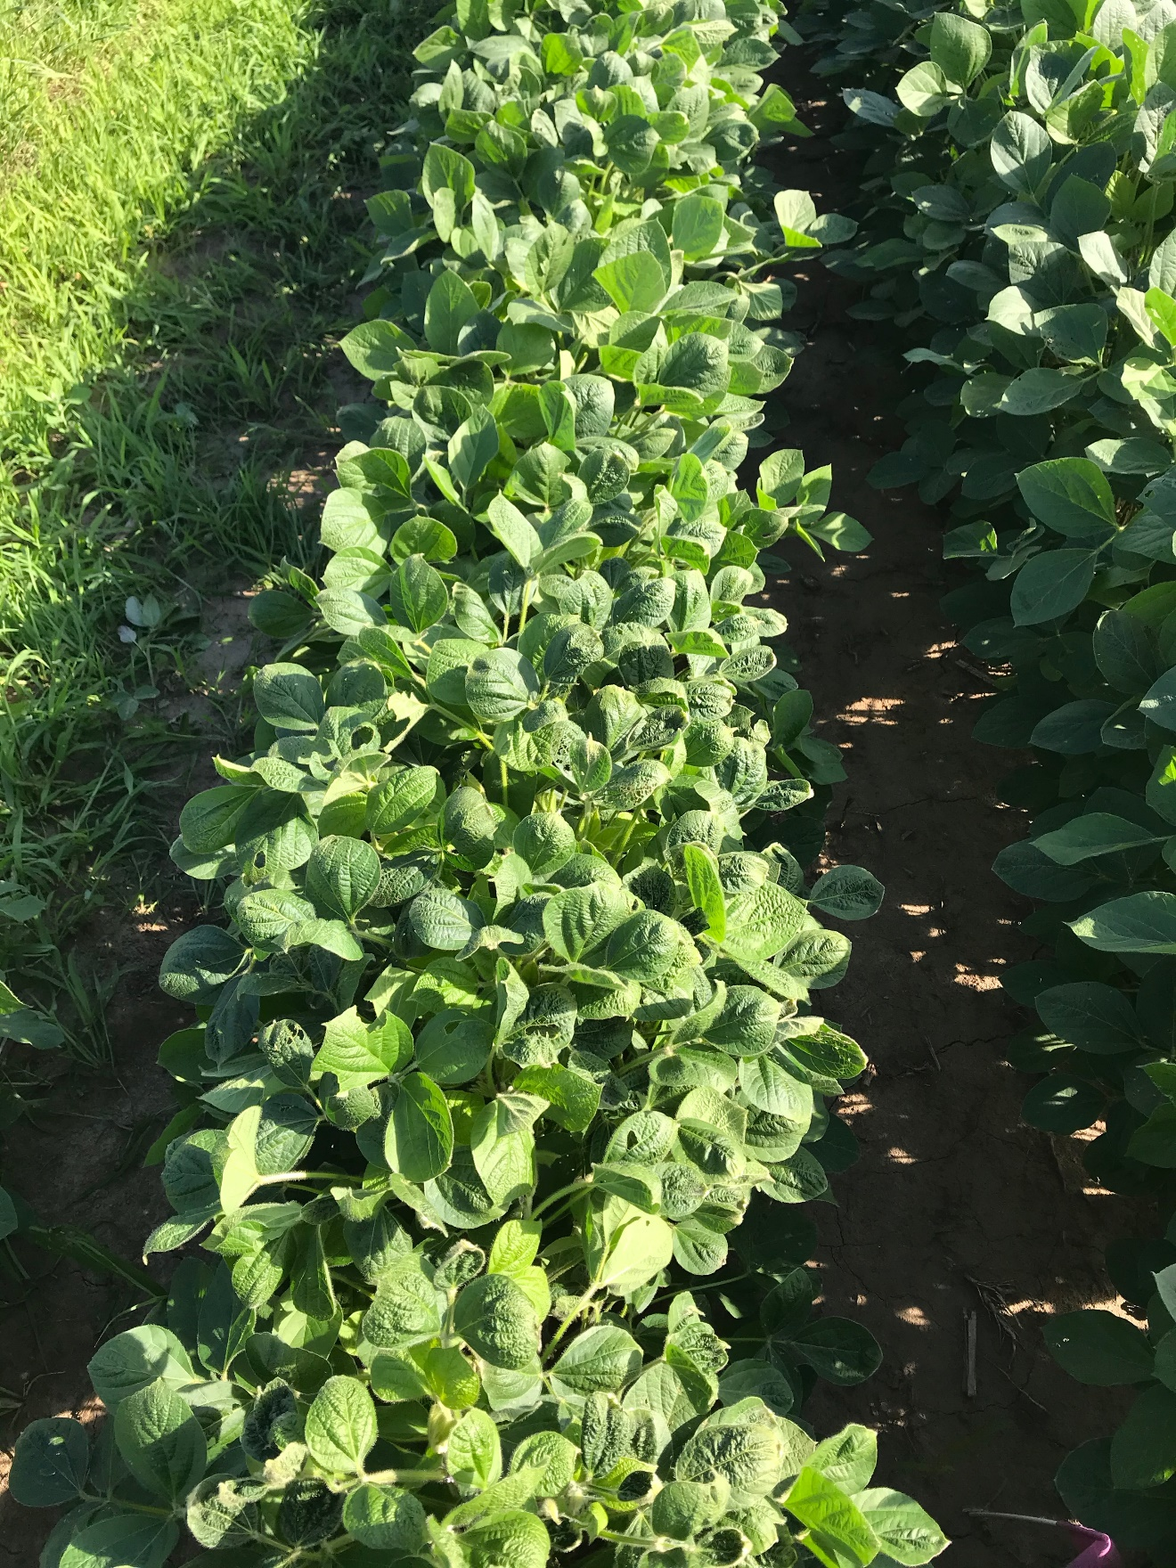

Figure 1. XtendiMax with VaporGrip + Roundup PowerMax at 28 DAT.

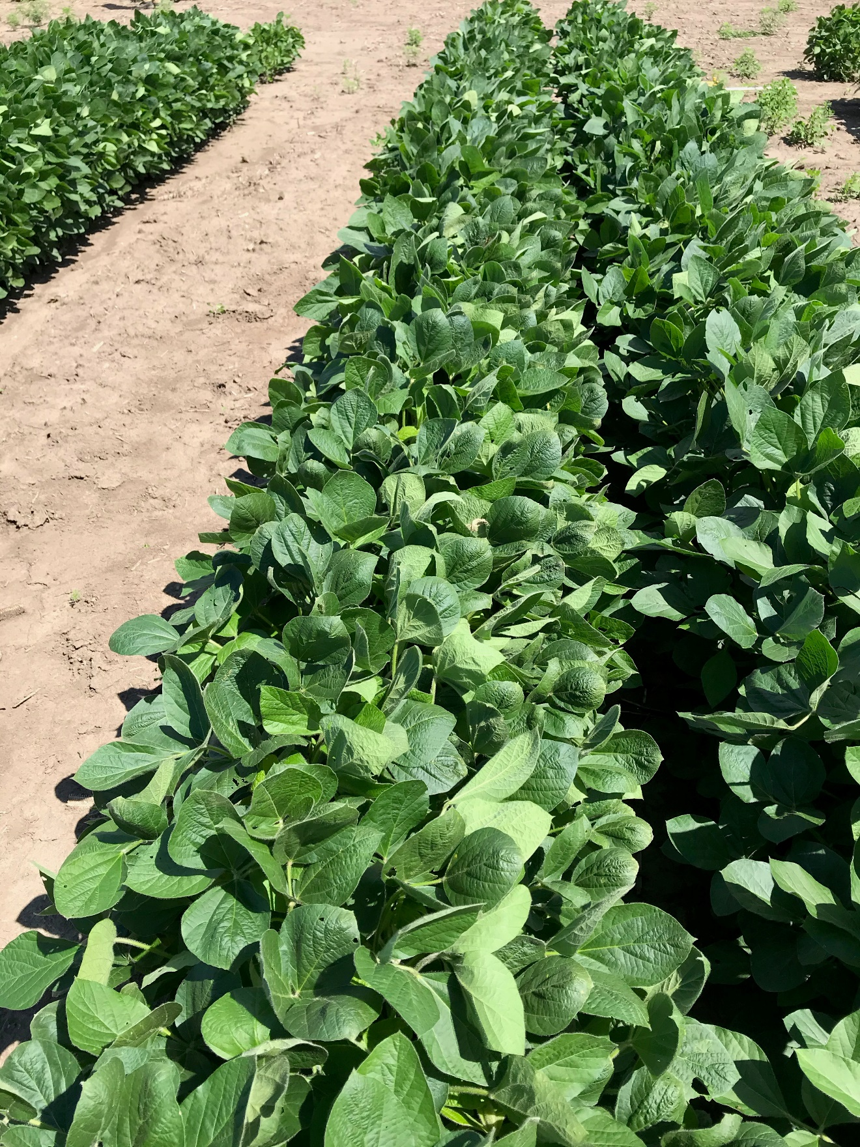

Figure 2. XtendiMax with VaporGrip + Roundup PowerMax + Intact at 28 DAT.

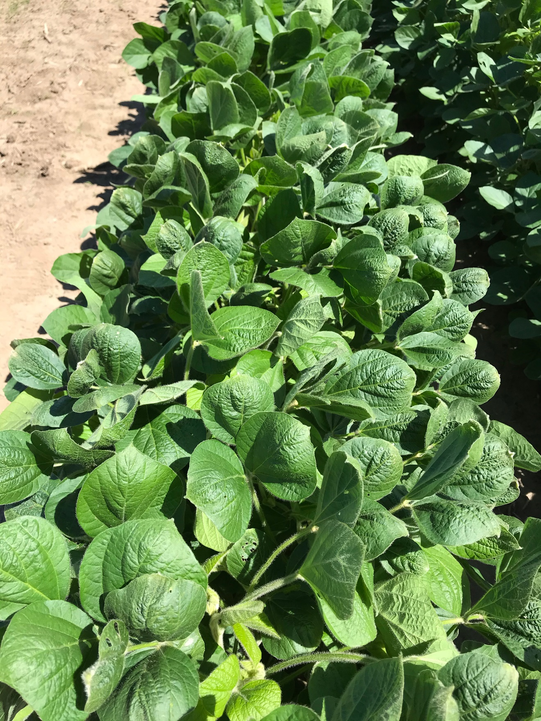

Figure 3. XtendiMax with VaporGrip + Roundup PowerMax + Impetro II at 28 DAT.

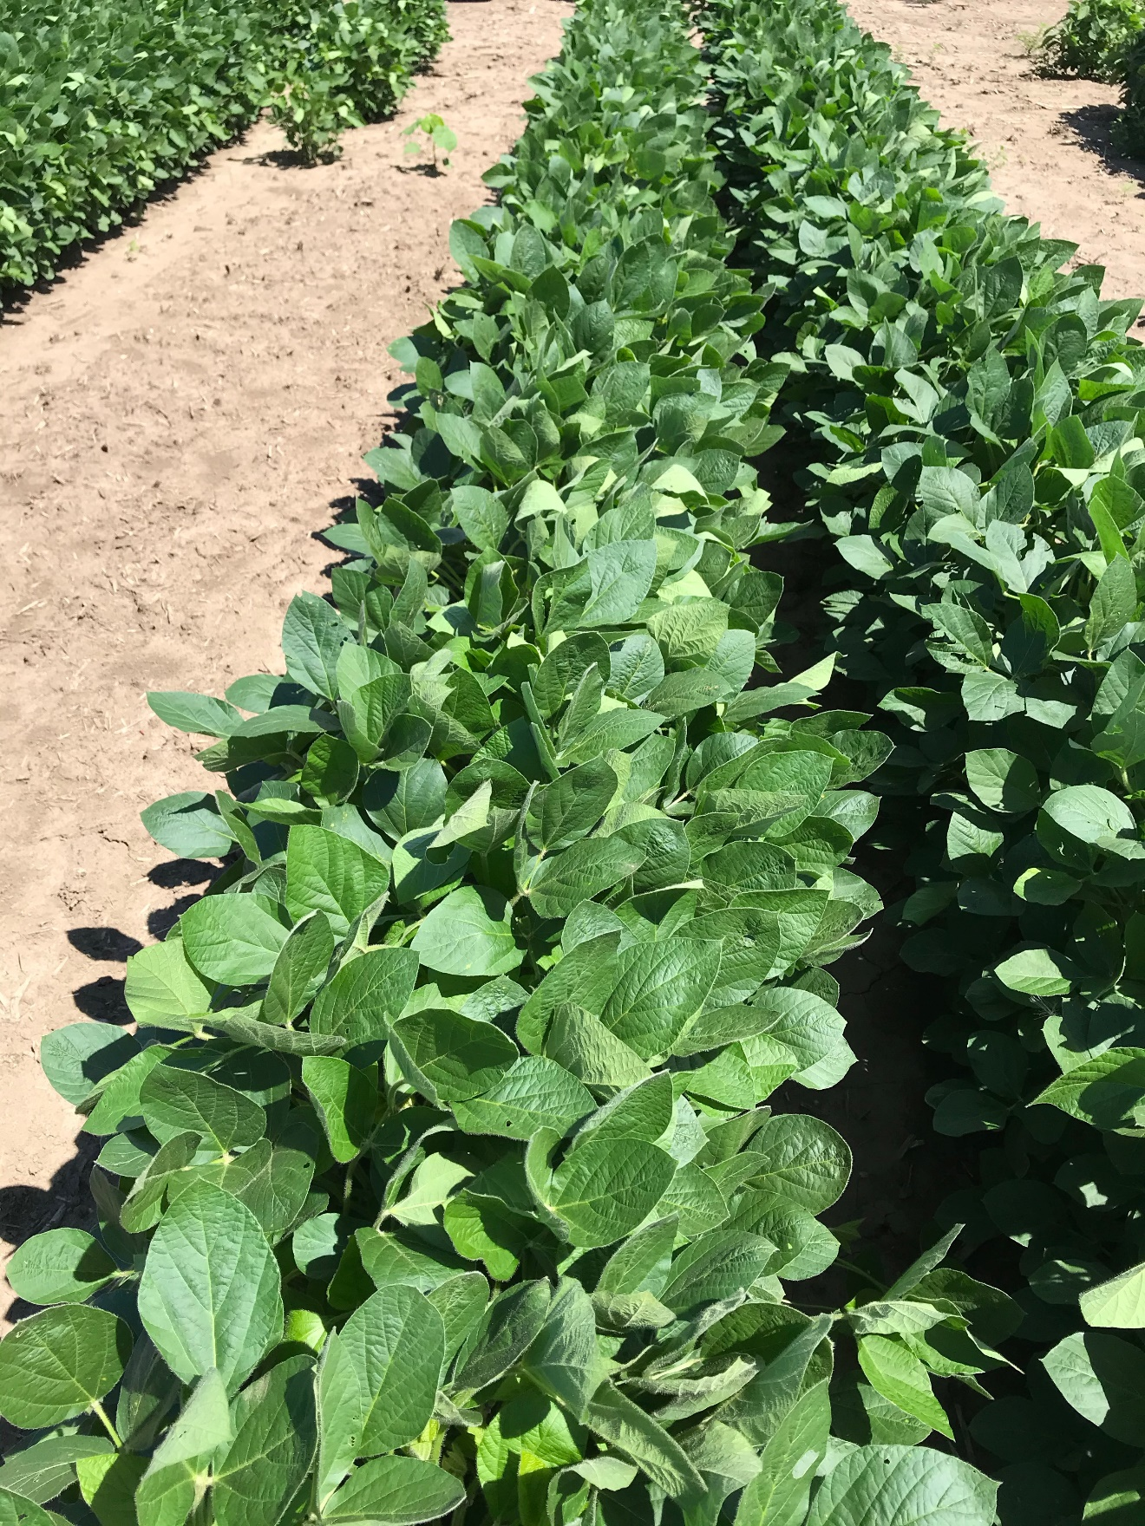

Figure 4. XtendiMax with VaporGrip + Roundup PowerMax + MON 51817 – VaporGrip at 28 DAT.

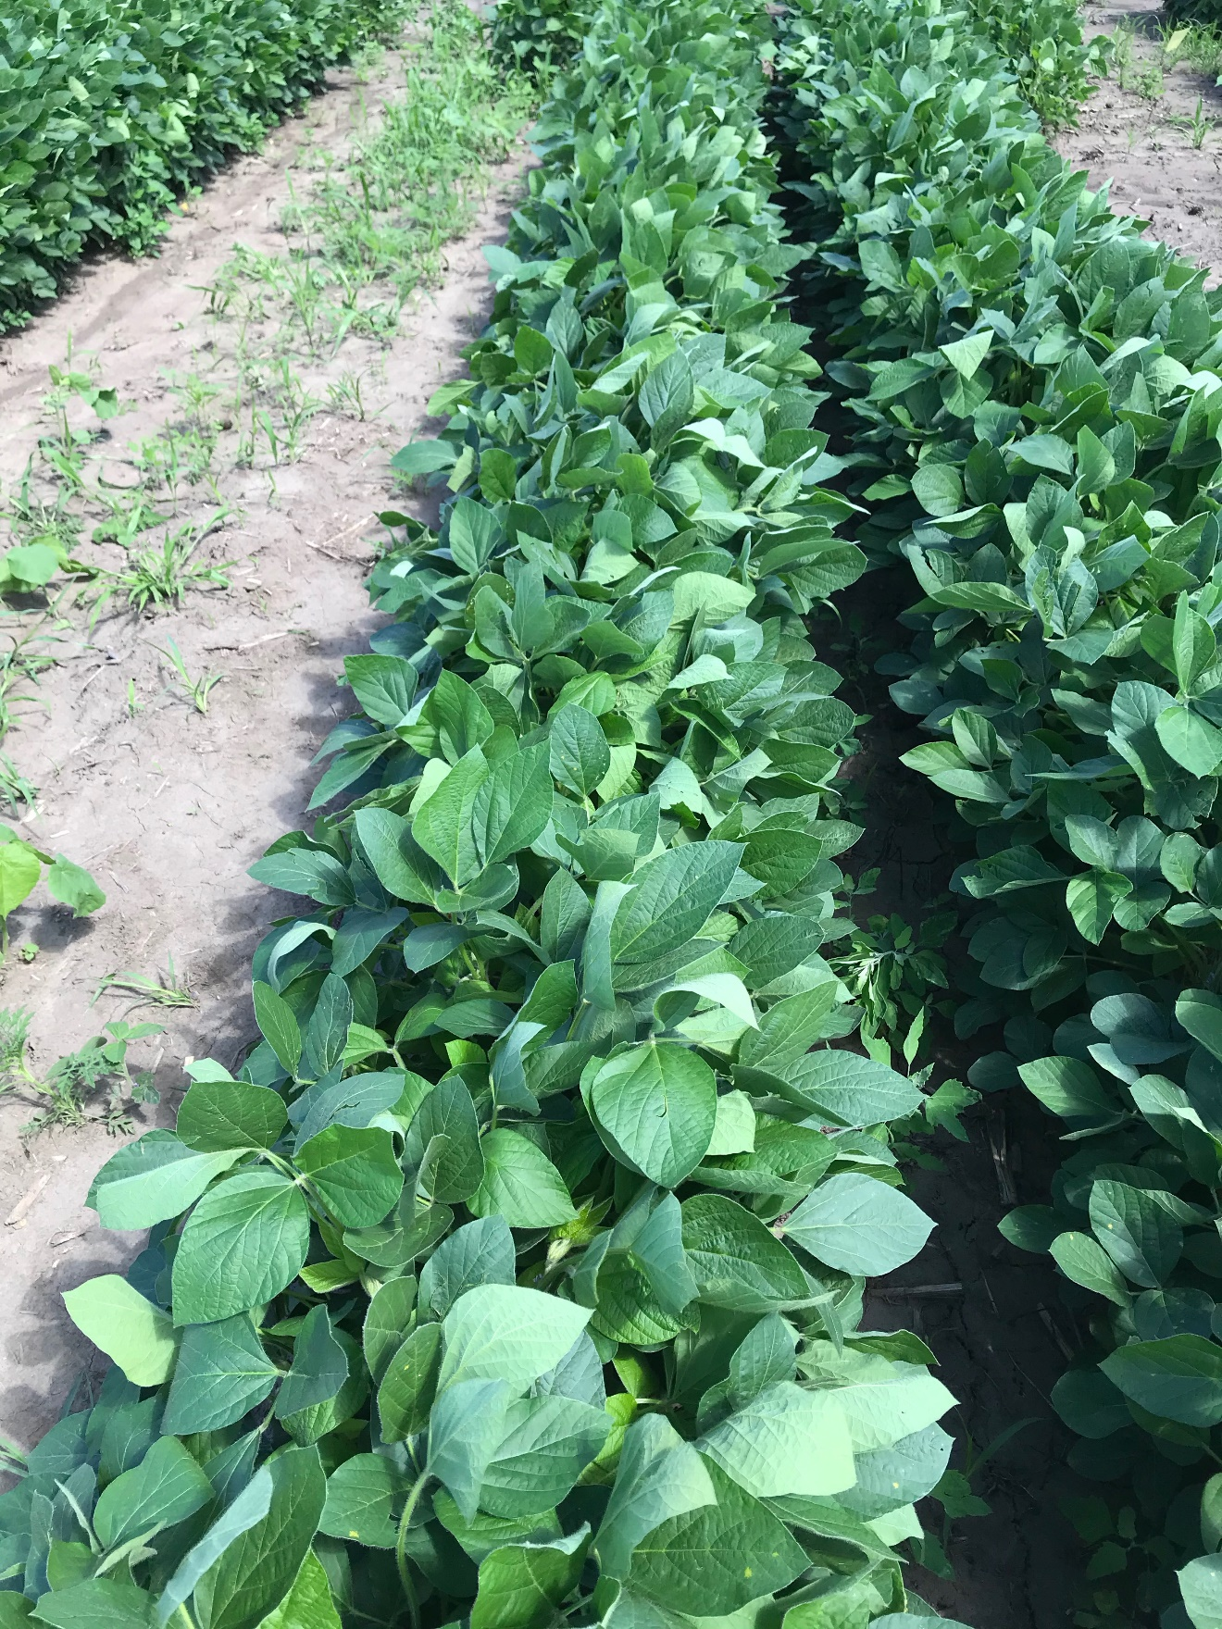

Figure 5. XtendiMax with VaporGrip + Roundup PowerMax + MON 51817 – VaporGrip + Intact at 28 DAT.

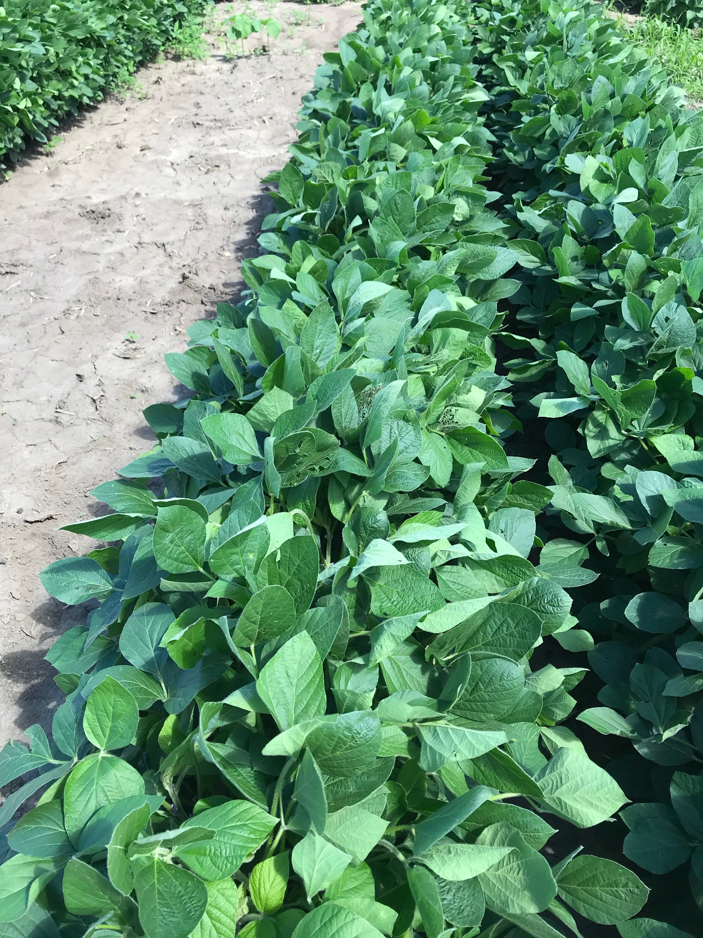

Figure 6. XtendiMax with VaporGrip + Roundup PowerMax + MON 51817 – VaporGrip + Impetro II at 28 DAT.

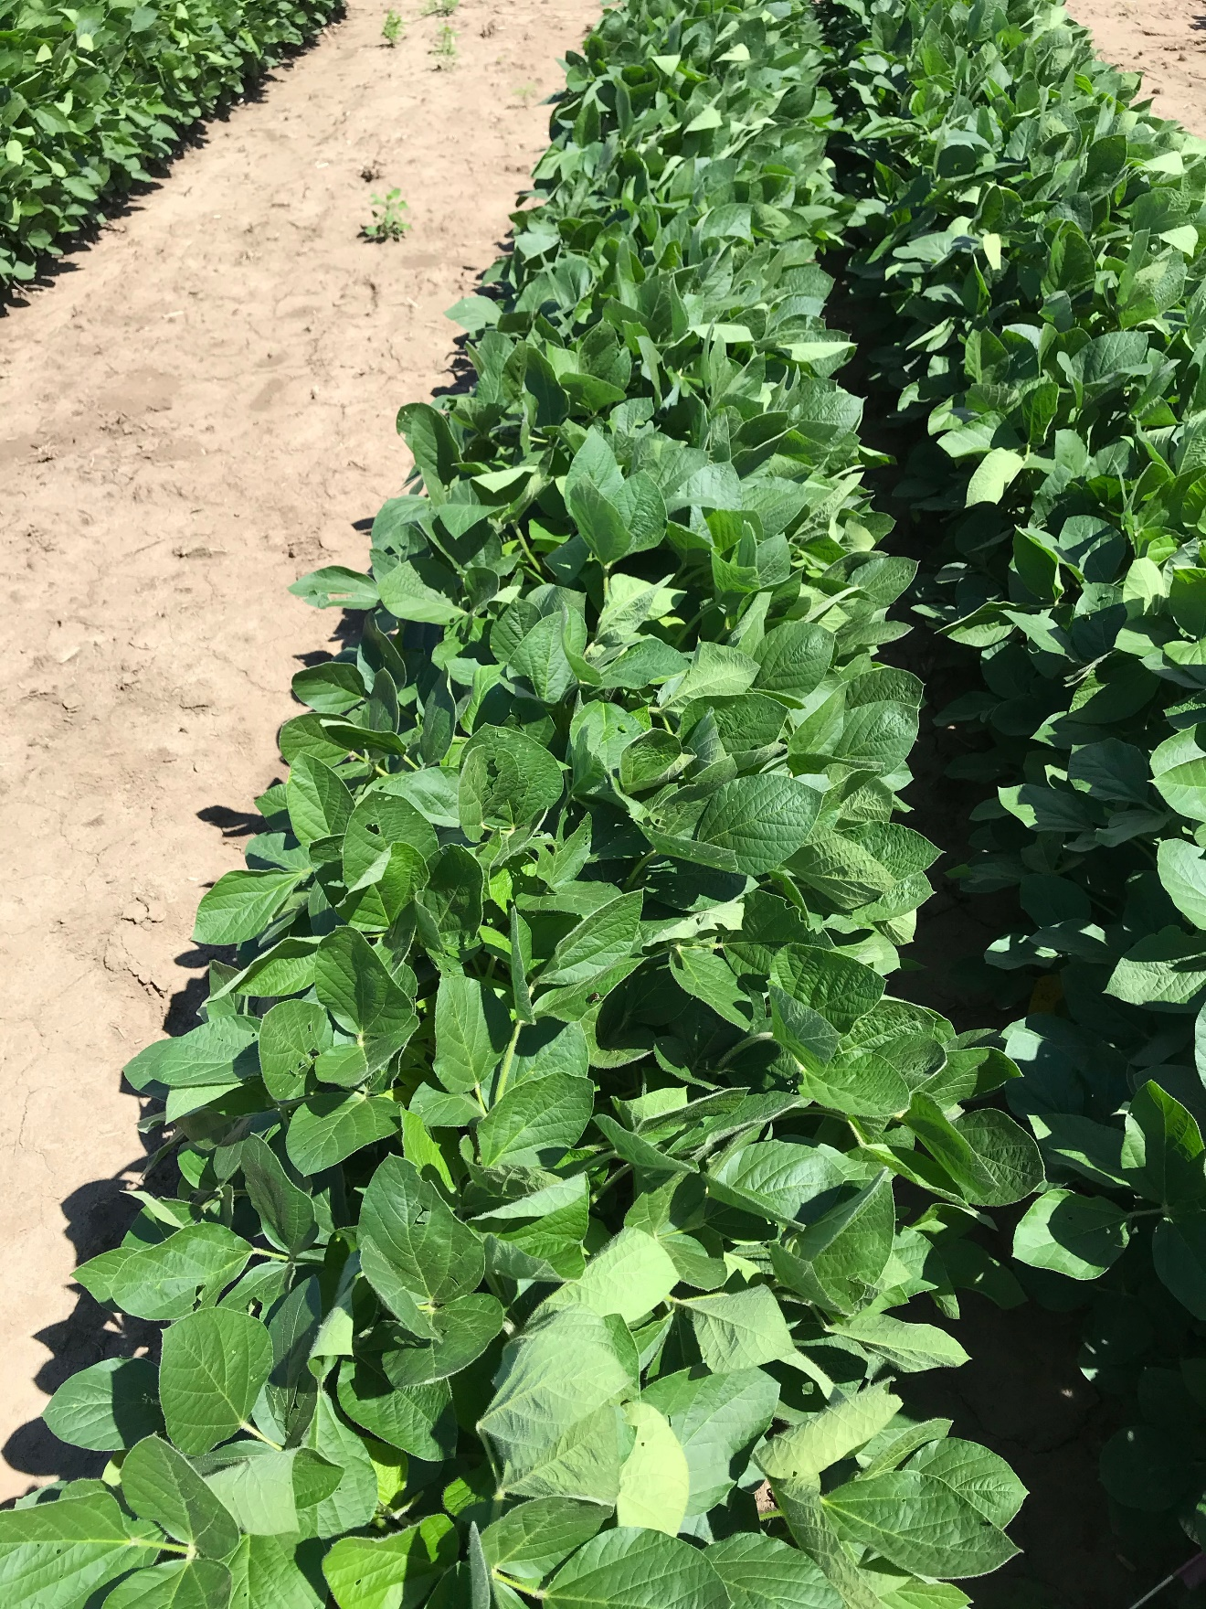

Figure 7. XtendiMax with VaporGrip + Roundup PowerMax + MON 301471 – VaporGrip + Guar at 28 DAT.

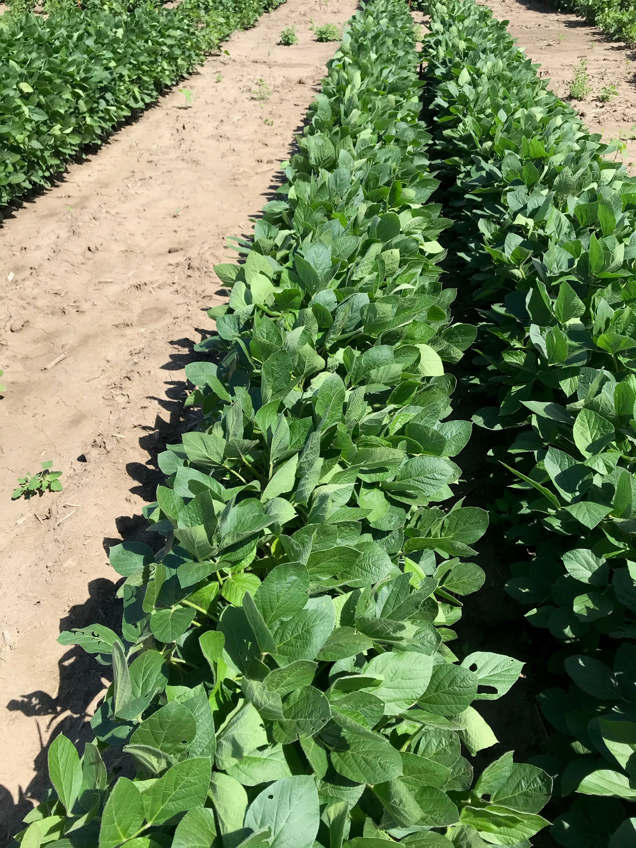

Figure 8. XtendiMax with VaporGrip + Roundup PowerMax + MON 301916 – VaporGrip + PCA at 28 DAT.

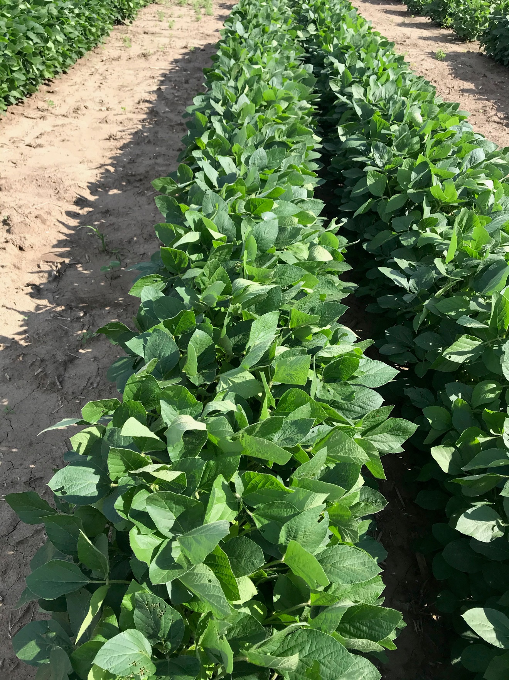

Figure 9. Nontreated Check at 28 DAT.

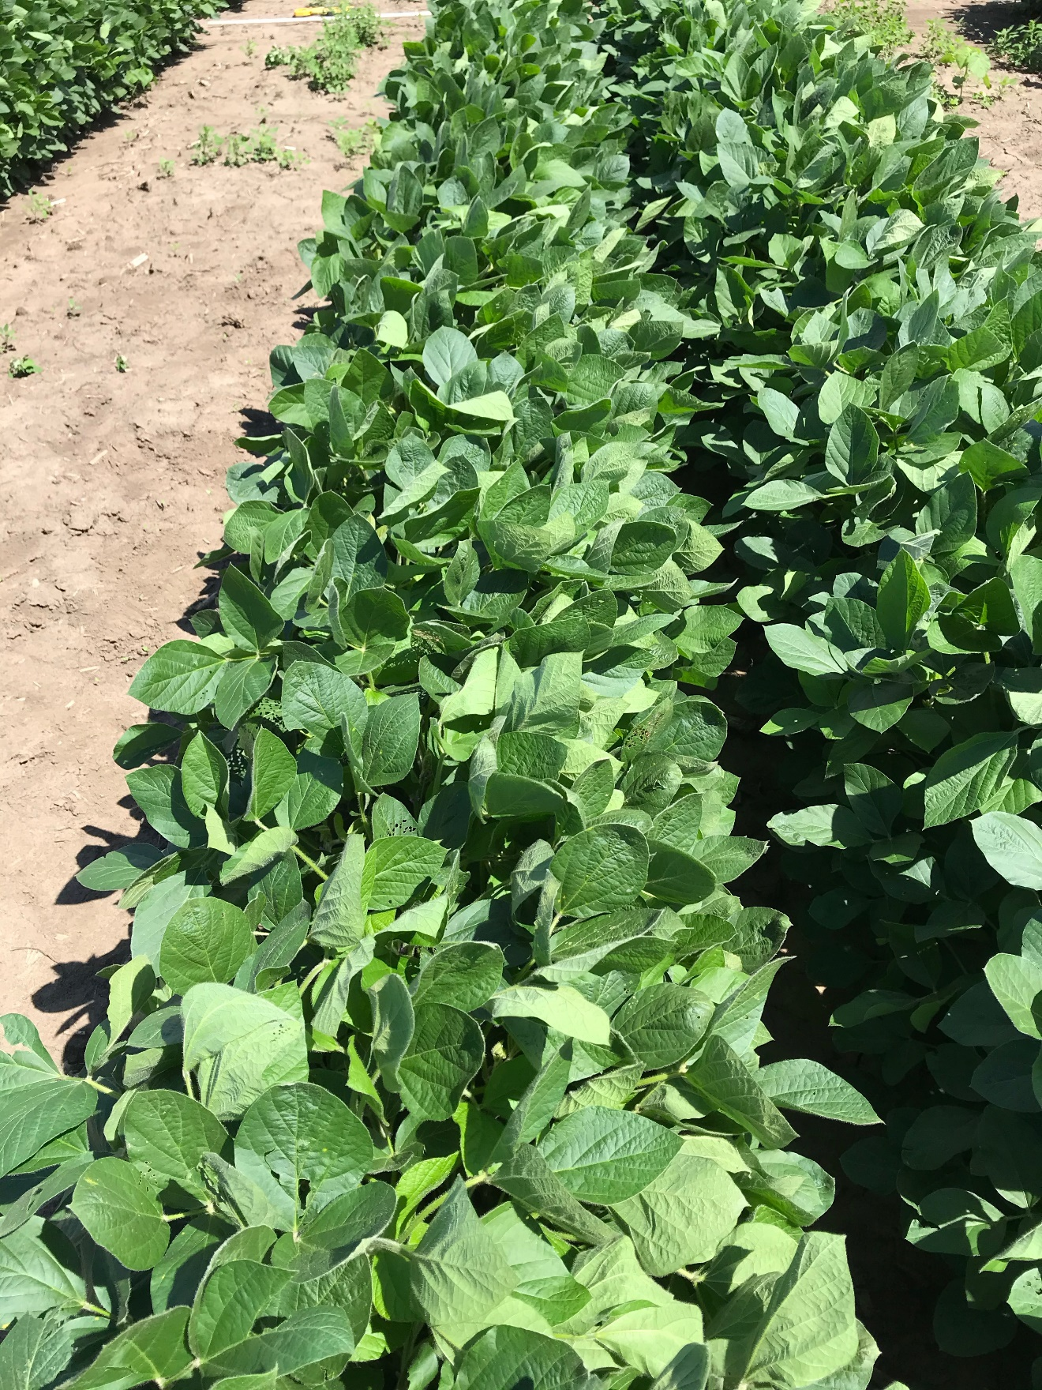

Figure 10. MON 119144 at 28 DAT.

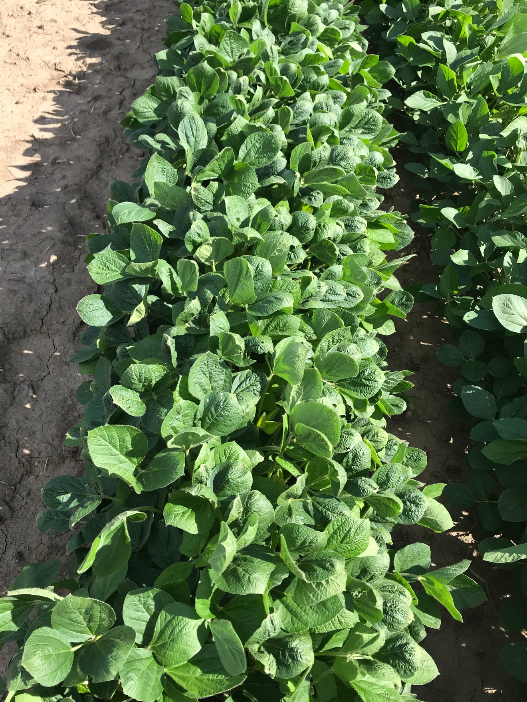

Figure 11. MON 119144 + Roundup PowerMax at 28 DAT.

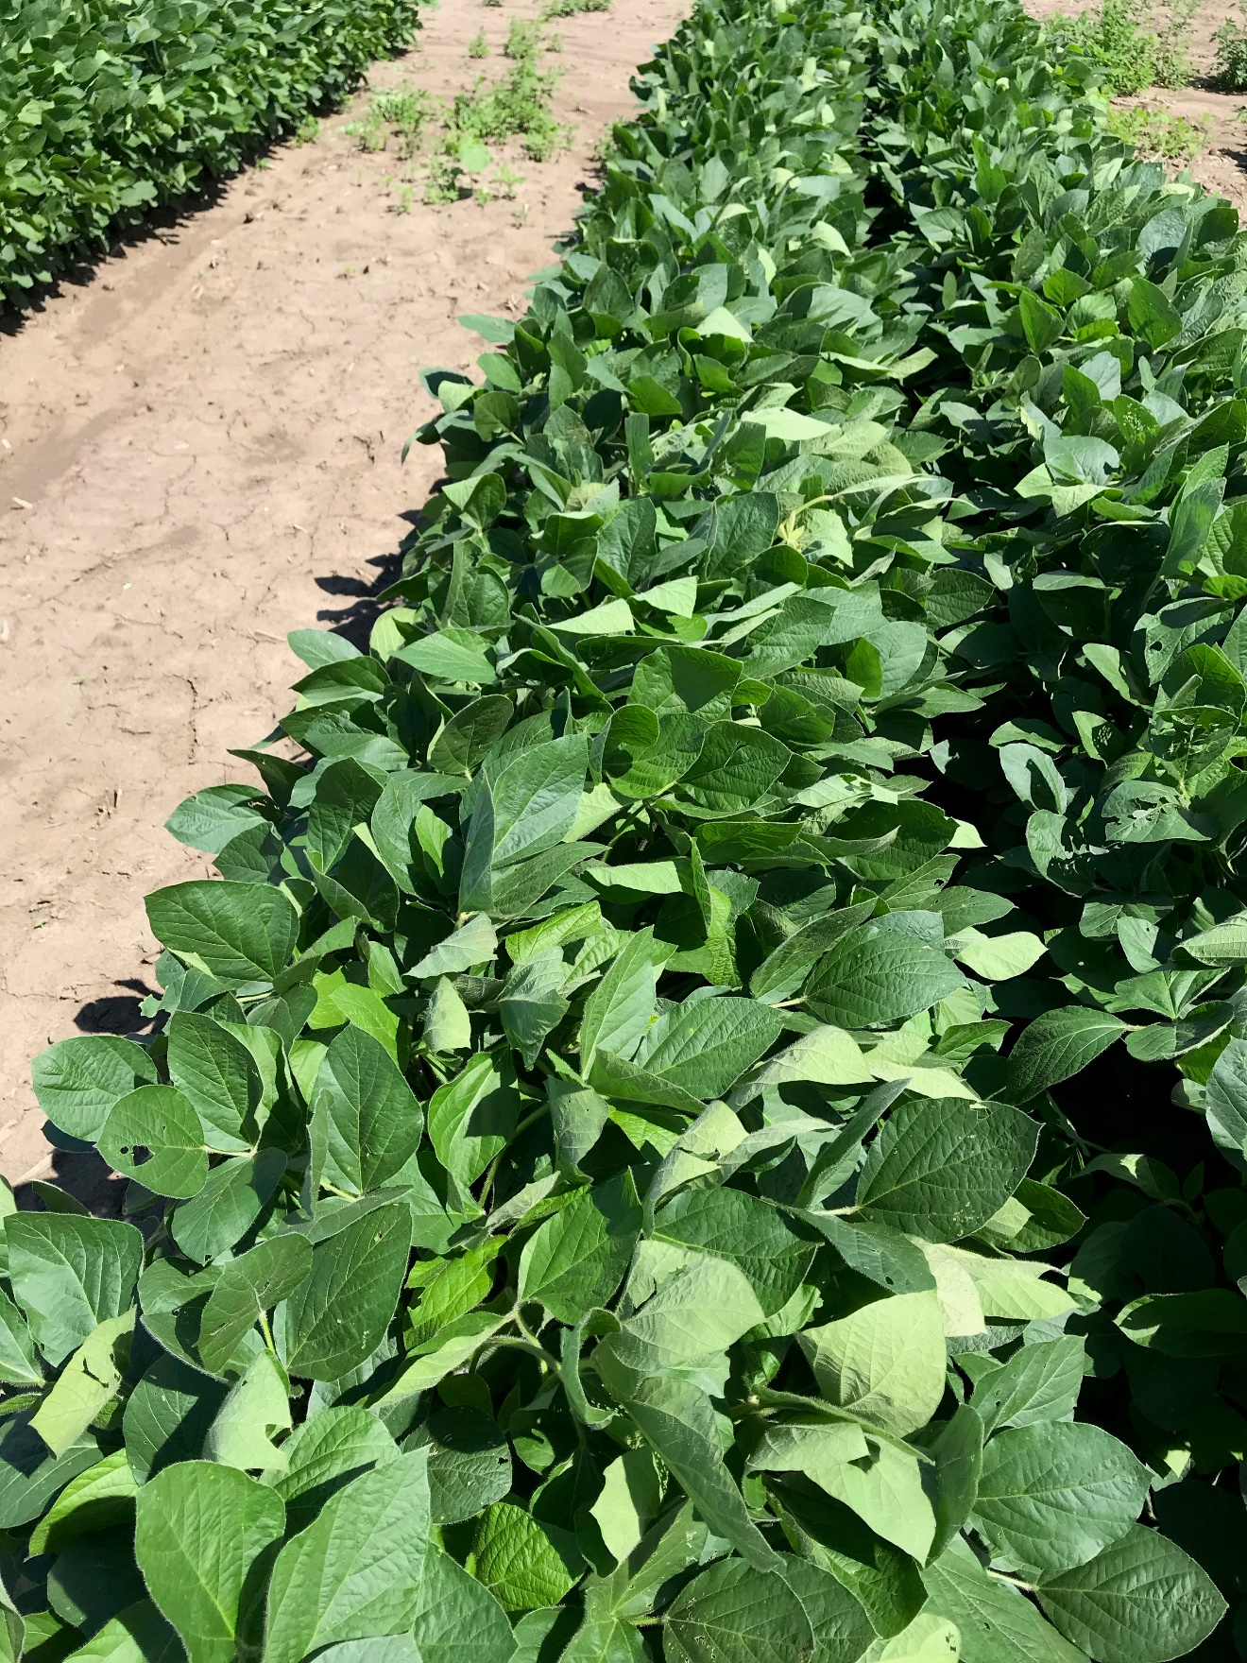

Figure 12. MON 119144 + MON 51817 – VaporGrip at 28 DAT.